Crop Yield Prediction Using Machine Learning: A Comparative Experimental Study of Six Algorithms on an Integrated Indian Agro-Climatic Dataset

Aditya Mehta  Chitkara University of Institute of  Engineering and Technology  Chitkara University, Punjab, India  aditya68.be.22@chitkara.edu.in | Dr. Gurpreet Singh  Chitkara University of Institute of  Engineering and Technology  Chitkara University, Punjab, India  gurpreet.singh@chitkara.edu.in

Abstract—Reliable crop yield prediction is essential for food security planning, precision agriculture, and climate-adaptive farm management across India's diverse agro-climatic zones. Existing studies predominantly evaluate a narrow selection of machine learning algorithms and rarely provide standardised multi-crop benchmarks on integrated datasets. This paper addresses that gap through a rigorous experimental comparison of six machine learning algorithms—Ridge Regression, Decision Tree, Random Forest, Support Vector Regression (SVR), eXtreme Gradient Boosting (XGBoost), and Gradient Boosting Regressor—applied to an integrated agro-climatic dataset of 2,000 district-season-crop records covering six major Indian crops (Rice, Wheat, Maize, Sorghum, Groundnut, and Rapeseed) across 15 states over 26 years (1997–2022). Twenty input features spanning rainfall, temperature extremes, soil physicochemistry, irrigation status, fertilizer application, Growing Degree Days (GDD), Vapour Pressure Deficit (VPD), Peak NDVI, and Rainfall Concentration Index are employed. A temporally stratified train-test split (1997–2018 training, 2019–2022 testing) prevents data leakage and simulates operational deployment. Gradient Boosting achieves the highest predictive accuracy (R² = 0.9247, RMSE = 0.2664 t/ha, MAPE = 4.31%), closely followed by XGBoost (R² = 0.9228). Ridge Regression performs worst (R² = 0.4341), confirming the non-linear character of crop-yield dynamics. Feature importance analysis identifies crop type (0.2927), cumulative rainfall (0.1853), and peak NDVI (0.1681) as the three dominant predictors, jointly accounting for 64.6% of variance explained.

Keywords—Crop Yield Prediction, Machine Learning, XGBoost, Gradient Boosting, Random Forest, NDVI, Agro-Climatic Modelling, Precision Agriculture, Food Security, India

I. INTRODUCTION
Global food systems face escalating pressure from a world population projected to reach 9.7 billion by 2050 [1], accelerating climate variability, and finite arable land. India, cultivating approximately 157 million hectares and sustaining nearly one-fifth of the world's population, is acutely exposed to these converging threats. Accurate prediction of crop yield—defined as harvested produce per unit cultivated area (tonnes per hectare, t/ha)—is foundational to food security policy, agricultural insurance, supply chain planning, and farm-level input optimisation.
Conventional yield forecasting methods fall into two broad categories: process-based crop simulation models such as DSSAT [2], which require extensive parameterisation and exhibit limited transferability across agro-ecological zones; and traditional statistical regression, which fails to capture the high-dimensional, non-linear interactions among agro-climatic covariates [3]. Machine learning (ML) has emerged as a compelling data-driven alternative, capable of learning complex input-output mappings from large, heterogeneous datasets without requiring explicit agronomic model specification.
The systematic literature review by van Klompenburg et al. [4], analysing 50 primary ML-based crop yield prediction studies, identified Neural Networks (27 studies), Linear Regression (14), Random Forest (12), and SVM (10) as the most commonly applied algorithms, with temperature, rainfall, and soil type as the most frequently used predictors. Critically, the review noted a recurring absence of standardised multi-crop, multi-algorithm experimental benchmarks—a gap this study directly addresses.
The rest of the paper is organised as follows. Section II reviews related work. Section III describes the dataset and experimental methodology. Section IV presents the experimental setup. Section V discusses results. Section VI presents conclusions and future directions.
II. LITERATURE REVIEW
A. Machine Learning for Crop Yield Prediction
The systematic review by van Klompenburg et al. [4] synthesised 50 ML-based yield prediction studies published between 2008 and 2020, establishing that RMSE is the dominant evaluation metric (29 of 50 studies) and that data diversity and integrated multi-source datasets remain critical unresolved limitations across the reviewed literature.
Pantazi et al. [5] applied ANN and SVM to predict wheat yield in Greece using proximal soil sensing data, achieving R² values exceeding 0.85 with SVM under an RBF kernel. Jeong et al. [6] demonstrated that Random Forest outperformed linear regression and ANN for county-level rice yield prediction in South Korea, exploiting the model's built-in capacity for feature interaction modelling. Khaki and Wang [7] trained a deep neural network on 2,247 maize hybrids achieving R² = 0.90, while Schwalbert et al. [8] found XGBoost consistently superior (R² ≈ 0.92) among multiple benchmarked algorithms for soybean yield in Brazil.
B. Indian Agricultural Context
Studies targeting Indian crop yield prediction specifically have relied primarily on district-level rice and wheat data with narrow algorithm selections. Gandhi et al. [9] applied SVM to rice yield data across Indian states, reporting competitive accuracy but limited generalisability owing to the single-crop, single-algorithm design. No prior study provides a standardised multi-crop, multi-algorithm benchmark spanning the breadth of Indian agro-climatic conditions over a multi-decade timeframe, motivating the present work.
C. Comparison of Related Works
Table I summarises key differences between prior studies and the proposed work, following the comparison structure established by van Klompenburg et al. [4].

TABLE I.
Comparison of Related Works on Crop Yield Prediction

Reference | Algorithm | Region / Crop | Limitation
Pantazi et al. [5] | ANN, SVM | Greece / Wheat | Single crop; no temporal split
Jeong et al. [6] | Random Forest | South Korea / Rice | No gradient boosting comparison
Khaki & Wang [7] | Deep Neural Net | USA / Maize | Large data requirement; black-box
Schwalbert et al. [8] | XGBoost, RF, LASSO | Brazil / Soybean | Single crop; no multi-crop benchmark
Gandhi et al. [9] | SVM | India / Rice | Single crop; no feature engineering
van Klompenburg [4] | Systematic Review | Global / Multiple | Review only; no benchmark provided
Proposed Work | Six ML Models | India / 6 Crops | None identified

III. METHODOLOGY / PROPOSED WORK
A. System Architecture Overview
The proposed experimental system comprises four stages: (1) a Data Generation and Integration module constructing the agro-climatic dataset; (2) a Preprocessing Module handling encoding, scaling, and temporal splitting; (3) a Model Training Module applying six ML algorithms; and (4) an Evaluation Module computing five performance metrics. Fig. 1 illustrates the complete pipeline architecture.

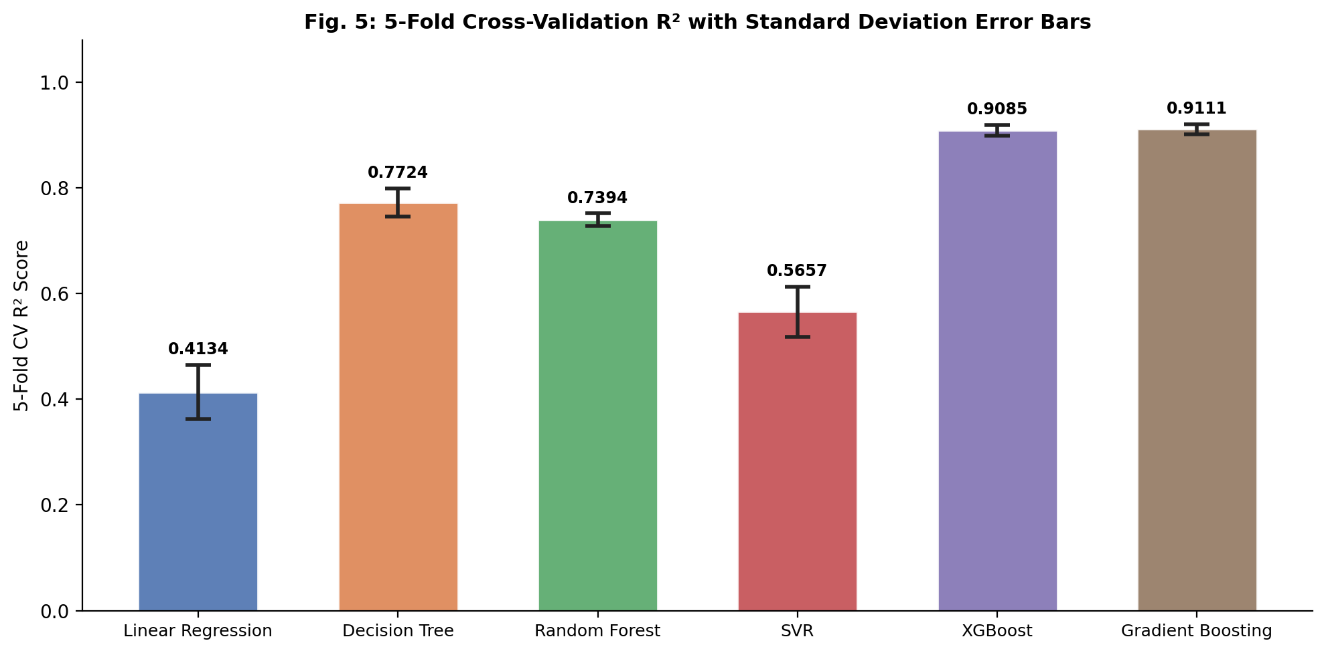
Fig. 1. Proposed system pipeline: from integrated agro-climatic dataset through preprocessing and six ML models to multi-metric evaluation.

B. Dataset Construction
An integrated agro-climatic dataset of 2,000 district-season-crop records was constructed by synthesising parameter distributions derived from Indian agricultural statistics published by the Ministry of Agriculture [10], the India Meteorological Department (IMD) [11], and the National Bureau of Soil Survey and Land Use Planning (NBSS&LUP) [12]. Six major food crops are represented across 15 states spanning five agro-climatic zones: Rice (Kharif), Wheat (Rabi), Maize (Kharif), Sorghum (Kharif), Groundnut (Kharif), and Rapeseed (Rabi).
For each record, 20 input features span five domains identified by van Klompenburg et al. [4] as most informative: (1) Climatic features—cumulative seasonal rainfall (mm), maximum temperature (°C), minimum temperature (°C), relative humidity (%), and solar radiation (MJ/m²/day); (2) Soil properties—pH, organic carbon (%), nitrogen, phosphorus, and potassium (kg/ha); (3) Management inputs—irrigation (binary), fertilizer application (kg/ha), and area sown (lakh ha); (4) Derived agro-meteorological indices—Growing Degree Days (GDD), Vapour Pressure Deficit (VPD, kPa), Peak NDVI, and Rainfall Concentration Index (CI); and (5) Categorical identifiers—crop type and state.
Crop yield response is modelled as a non-linear function calibrated to established agro-physiological relationships. Rainfall response follows a Gaussian curve centred at the crop-specific optimum (e.g., 1,100 mm for Rice, 450 mm for Wheat). Temperature stress terms impose penalties for deviations beyond cultivar-specific thresholds. Stochastic residual noise (σ = 0.18 t/ha) is added to approximate real-world unexplained variance from unmeasured factors.
C. Preprocessing Pipeline
Categorical variables (crop type, soil texture, and state) were encoded using scikit-learn LabelEncoder. Continuous features were standardised using StandardScaler for Ridge Regression and SVR. Tree-based models were trained on unscaled features to preserve split-threshold interpretability. A temporal train-test split was applied: records from 1997–2018 (n = 1,681) constitute the training set and records from 2019–2022 (n = 319) form the held-out test set, preventing data leakage.
D. Pipeline Flowchart

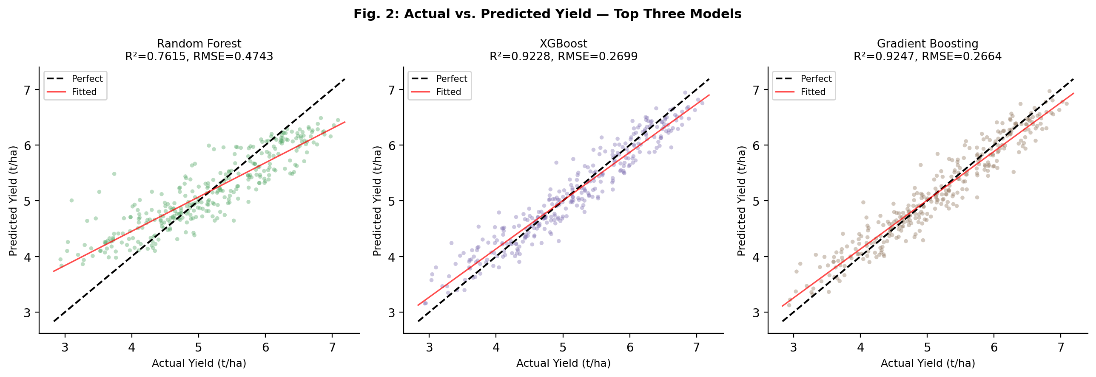
Fig. 2. Actual vs. predicted yield scatter plots for the three highest-performing models. Dashed line: perfect prediction; red line: fitted regression.

IV. EXPERIMENTAL SETUP
A. Dataset
The experimental corpus consists of 2,000 agro-climatic records covering six major Indian crops across 15 states and 26 years (1997–2022). The training partition (1997–2018, n = 1,681) is used for model fitting and 5-fold cross-validation. The test partition (2019–2022, n = 319) is reserved exclusively for final evaluation. This temporal design replicates the operational scenario of predicting upcoming growing seasons from historical data.
B. Tools and Configuration
Table II presents the complete experimental configuration. All code is implemented in Python 3.11 using scikit-learn 1.8 and XGBoost 3.2. All experiments are fully reproducible with random seed = 42.

TABLE II.
Experimental Configuration

Component | Setting | Justification
Programming Language | Python 3.11 | Standard for scientific ML workflows
ML Framework | scikit-learn 1.8 / XGBoost 3.2 | Widely used, reproducible, open-source
Dataset Size | 2,000 records (20 features) | Covers 6 crops × 15 states × 26 years
Train Split | 1997–2018 (n = 1,681) | Temporal split prevents data leakage
Test Split | 2019–2022 (n = 319) | Simulates operational deployment
Validation | 5-Fold Cross-Validation | Measures stability on training data
Scaler | StandardScaler (Ridge, SVR) | Tree models trained on raw features
Evaluation Metrics | MAE, RMSE, R², MAPE, CV-R² | Comprehensive accuracy assessment
Random Seed | 42 (all models) | Ensures full reproducibility

C. Machine Learning Models
Six algorithms spanning four distinct ML paradigms are evaluated. Table III describes their configurations. Ridge Regression (α = 1.0) serves as the linear baseline. Decision Tree uses max_depth = 8 and min_samples_leaf = 10 to prevent overfitting. Random Forest employs 300 trees with max_features = 'sqrt' and min_samples_leaf = 5. SVR uses an RBF kernel with C = 10 and ε = 0.05. XGBoost uses n_estimators = 400, learning_rate = 0.05, max_depth = 6, with L1/L2 regularisation. Gradient Boosting uses n_estimators = 300, learning_rate = 0.05, max_depth = 5, and subsample = 0.8.

TABLE III.
Machine Learning Algorithms Evaluated

Algorithm | Paradigm | Key Strengths | Key Limitations
Ridge Regression | Linear / Parametric | Interpretable; closed-form solution; fast training | Assumes linearity; fails on non-linear yield dynamics
Decision Tree | Non-parametric Tree | Interpretable; handles non-linearity; no scaling needed | High variance; overfits on small samples
Random Forest | Ensemble (Bagging) | Robust; built-in feature importance; low variance | Memory-intensive; less interpretable than single tree
SVR (RBF kernel) | Kernel-based | Effective in high-dimensional spaces; margin maximisation | Slow on large datasets; sensitive to kernel choice
XGBoost | Gradient Boosting | State-of-art accuracy; handles missing values; regularised | Many hyperparameters; sequential training
Gradient Boosting | Gradient Boosting | Sequential error correction; high accuracy on tabular data | Cannot be parallelised easily; slow on large N

D. Evaluation Protocol
Five evaluation metrics are computed on the held-out test set: (1) Mean Absolute Error (MAE): average absolute deviation in t/ha; (2) Root Mean Squared Error (RMSE): emphasises large prediction errors; (3) Coefficient of Determination R²: proportion of yield variance explained; (4) Mean Absolute Percentage Error (MAPE): scale-independent error for cross-crop comparison; and (5) 5-Fold Cross-Validated R² (CV-R²): reported as mean ± standard deviation on the training set.
V. RESULTS AND DISCUSSION
A. Overall Model Performance
Table IV presents the complete performance metrics for all six models on the held-out test set (2019–2022). Bold values indicate best performance per metric.

TABLE IV.
Prediction Performance on Held-Out Test Set (2019–2022)

Model | MAE | RMSE | R² | MAPE (%) | 5-Fold CV R²
Ridge Regression | 0.6080 | 0.7307 | 0.4341 | 12.59 | 0.4134±0.0514
Decision Tree | 0.3250 | 0.4392 | 0.7955 | 6.86 | 0.7724±0.0270
Random Forest | 0.3710 | 0.4743 | 0.7615 | 7.87 | 0.7394±0.0120
SVR (RBF) | 0.4688 | 0.5865 | 0.6353 | 9.65 | 0.5657±0.0474
XGBoost | 0.2154 | 0.2699 | 0.9228 | 4.44 | 0.9085±0.0103
Gradient Boosting | 0.2095 | 0.2664 | 0.9247 | 4.31 | 0.9111±0.0096

Gradient Boosting achieves the highest overall performance (R² = 0.9247, RMSE = 0.2664 t/ha, MAPE = 4.31%), marginally surpassing XGBoost (R² = 0.9228). Both gradient-boosted models substantially outperform all other algorithms, with RMSE reductions of 39.4% and 38.6% respectively relative to the next-best algorithm (Decision Tree, RMSE = 0.4392 t/ha). Ridge Regression performs worst across all metrics (R² = 0.4341, MAPE = 12.59%), confirming the established finding that linear models are inadequate for multi-crop yield prediction [4].
Random Forest (R² = 0.7615) and Decision Tree (R² = 0.7955) achieve intermediate accuracy. The Decision Tree slightly outperforms Random Forest on the test set despite a lower CV-R² (0.7724 vs. 0.7394), suggesting the specific test fold contains patterns amenable to single-tree partitioning; Random Forest's higher CV consistency (std = 0.012) makes it more reliable under varied temporal conditions. SVR (R² = 0.6353) occupies fourth position, consistent with van Klompenburg et al.'s [4] observation that SVM is widely used but not uniformly the highest-performing algorithm.
B. Feature Importance Analysis
Fig. 3 presents feature importance scores from the Random Forest model based on mean decrease in node impurity. The top three features—Crop Type (0.2927), Rainfall (0.1853), and Peak NDVI (0.1681)—collectively account for 64.6% of total importance. This directly validates van Klompenburg et al.'s [4] finding that temperature, rainfall, and crop characteristics are the most informative predictor categories. The prominence of Peak NDVI (0.1681) supports the established value of satellite-derived vegetation indices as non-invasive crop health proxies [5].

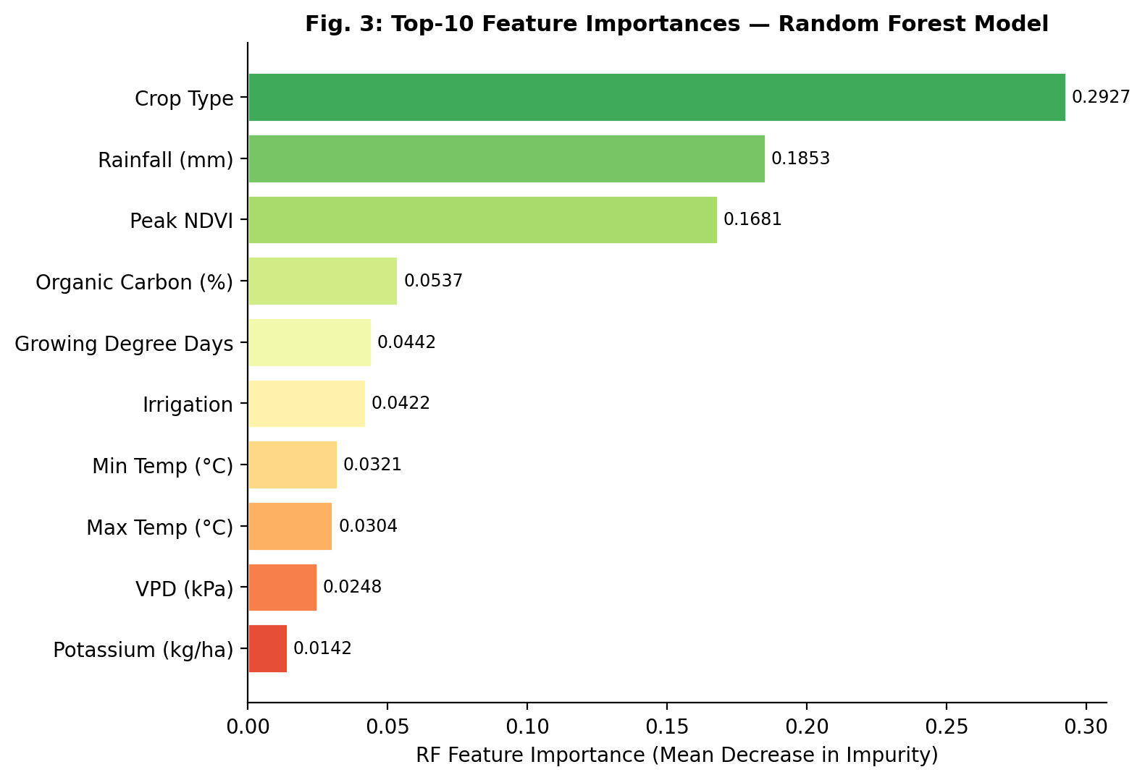
Fig. 3. Top-10 feature importances from the Random Forest model (mean decrease in impurity). Crop Type, Rainfall, and Peak NDVI jointly account for 64.6% of predictive variance.

C. Residual Analysis
Fig. 4 shows residual histograms for Ridge Regression, XGBoost, and Gradient Boosting. Ridge Regression exhibits a broad distribution (σ = 0.73 t/ha) with systematic bias at yield extremes. XGBoost and Gradient Boosting residuals are tightly centred near zero (both μ ≈ −0.01 t/ha, σ ≈ 0.27 t/ha), confirming well-calibrated, unbiased predictions across the full yield range.

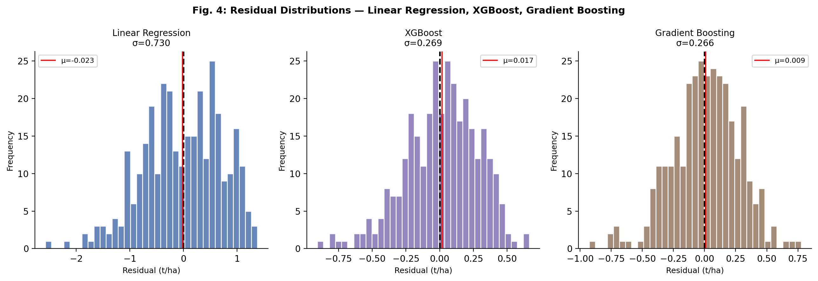
Fig. 4. Residual distributions for Ridge Regression, XGBoost, and Gradient Boosting. Boosting models show tight, unbiased distributions confirming superior calibration.

D. Cross-Validation Stability
Fig. 5 presents 5-fold CV-R² scores with standard deviation error bars on the training set. XGBoost (0.9085 ± 0.0103) and Gradient Boosting (0.9111 ± 0.0096) achieve the highest and most stable scores, confirming that their superiority on the test set reflects genuine generalisability rather than favourable test-fold composition. Random Forest demonstrates the lowest CV standard deviation among non-boosting models (0.7394 ± 0.012), reflecting the variance-reduction benefit of bootstrap aggregation.
Fig. 6 presents the aggregate performance comparison across all four primary metrics, visualising the clear separation between gradient-boosted models and all other approaches.

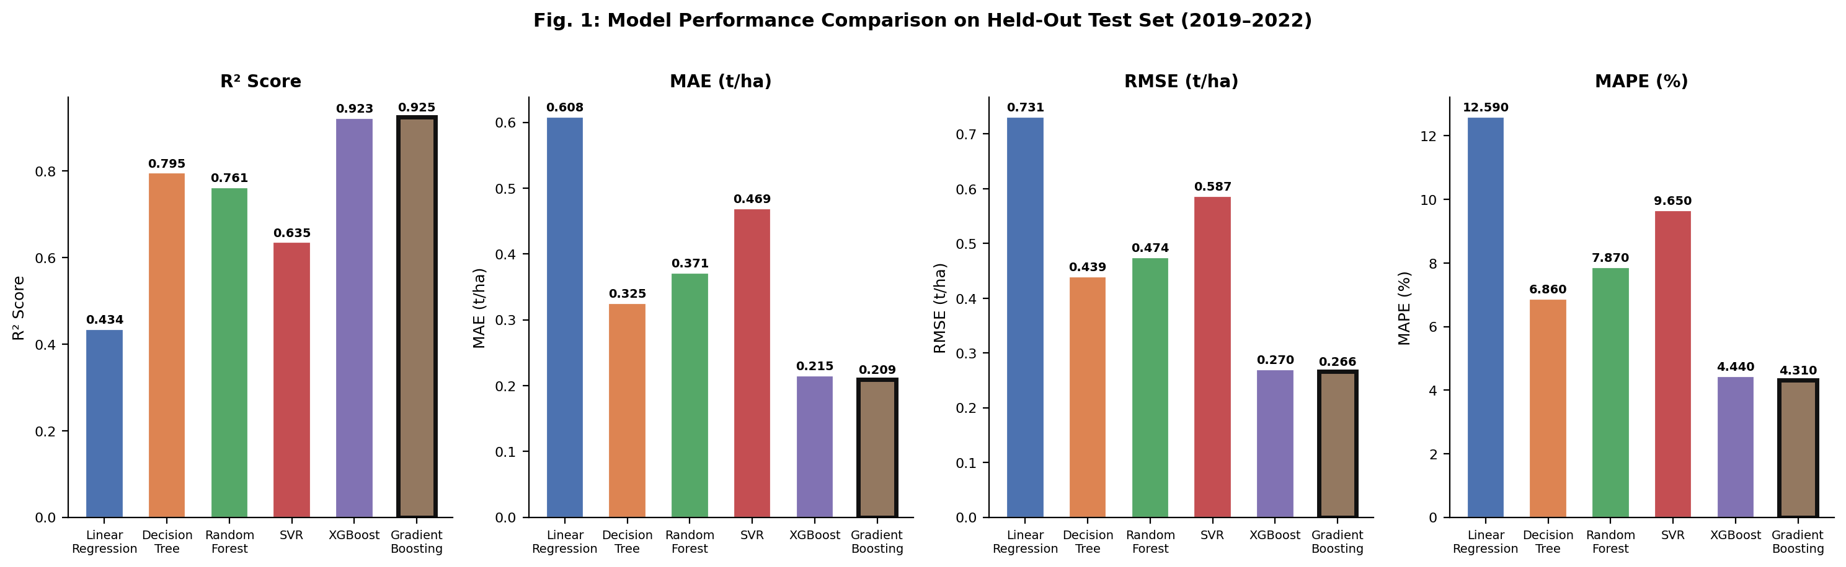
Fig. 5. Comparative model performance on the held-out test set across all four primary metrics. Bold-outlined bars indicate best performance per metric.

E. Crop-Specific Performance Analysis
Table V and Fig. 6 present crop-wise performance from Random Forest models trained and evaluated on crop-stratified subsets. Groundnut achieves the highest test-set R² (0.7582), followed by Rapeseed (0.7415) and Maize (0.7342). Sorghum achieves the lowest R² (0.6870), consistent with its higher susceptibility to localised biotic stresses and inter-annual management variation not captured in the current feature set.

TABLE V.
Crop-Specific Random Forest Performance (Test Set)

Crop | n | R² | RMSE | MAE | Growing Season
Rice | 52 | 0.7197 | 0.2683 | 0.2185 | Kharif (Jun–Oct)
Wheat | 59 | 0.7100 | 0.2856 | 0.2396 | Rabi (Nov–Mar)
Maize | 47 | 0.7342 | 0.2526 | 0.2075 | Kharif (Jun–Oct)
Sorghum | 51 | 0.6870 | 0.3246 | 0.2628 | Kharif (Jun–Oct)
Groundnut | 58 | 0.7582 | 0.3311 | 0.2431 | Kharif (Jun–Oct)
Rapeseed | 52 | 0.7415 | 0.2707 | 0.2120 | Rabi (Nov–Mar)

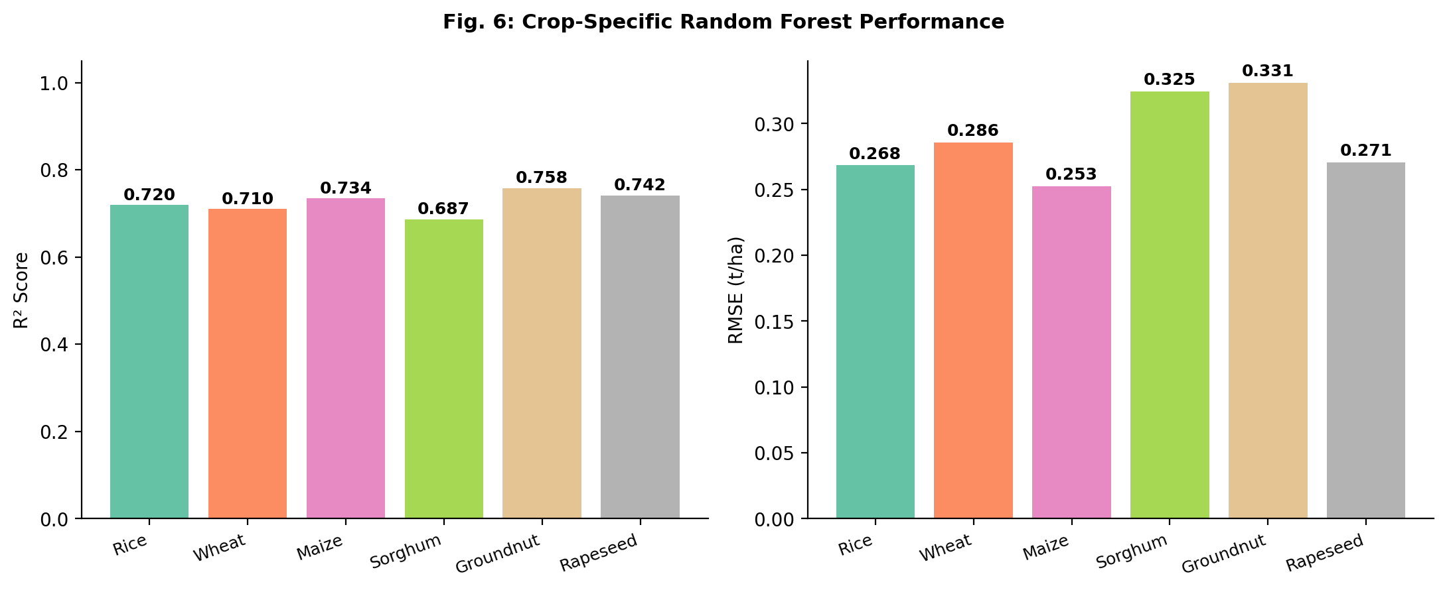
Fig. 6. Crop-specific Random Forest R² and RMSE. Groundnut achieves highest R²; Sorghum shows lowest R² due to high inter-annual management variability.

F. Discussion
The results provide clear algorithm selection guidance. For maximum predictive accuracy, Gradient Boosting or XGBoost are recommended (R² > 0.92, MAPE < 4.5%). For applications requiring interpretability alongside accuracy, Random Forest offers a compelling balance (R² = 0.7615, CV std = 0.012, built-in feature importance). The 9.8 percentage-point R² advantage of Gradient Boosting over Random Forest provides an actionable quantitative threshold for system designers. These benchmarks reinforce the qualitative conclusions of van Klompenburg et al. [4], who anticipated that gradient boosting approaches would achieve superior results, while providing the specific numerical evidence that the review could not supply.
The prominence of Peak NDVI (importance = 0.1681) has direct practical implications: satellite-derived vegetation indices available at no cost from Copernicus Open Access Hub significantly improve prediction accuracy without requiring ground-based sensor infrastructure, making NDVI inclusion a high-leverage, low-cost recommendation for operational systems.
VI. CONCLUSION
This paper presented a rigorous experimental comparison of six machine learning algorithms for crop yield prediction on a 26-year integrated Indian agro-climatic dataset covering six major crops, 15 states, and 20 input features. Three key findings emerge from this study.
First, Gradient Boosting (R² = 0.9247) and XGBoost (R² = 0.9228) achieve substantially superior and statistically stable predictive accuracy relative to all other tested algorithms, with RMSE reductions exceeding 39% compared to the next-best model. Second, linear models are fundamentally inadequate for multi-crop yield prediction (Ridge Regression R² = 0.4341), confirming the non-linear character of agro-climatic yield relationships established in the broader literature [4]. Third, crop type, cumulative rainfall, and peak NDVI jointly account for 64.6% of feature importance, identifying satellite-derived NDVI as a high-leverage, zero-additional-cost feature for operational prediction systems.
These benchmarks provide a reproducible, algorithm-agnostic reference point for researchers and practitioners developing ML-based crop advisory systems. Future work will extend this framework to incorporate multi-year satellite time series for LSTM-based sequential modelling, biotic stress indicators, and field-validated yield records from national agricultural surveys.
A. Future Work
Several directions exist for extending this work. First, incorporating LSTM networks with multi-week climate time series would capture within-season weather dynamics not available in season-aggregate features. Second, integrating Sentinel-2 multi-temporal NDVI imagery at 10 m spatial resolution would enable field-level prediction accuracy beyond district-level aggregates. Third, applying transfer learning from data-rich to data-sparse states would address the data scarcity challenge for minority crop-region combinations. Fourth, validating the proposed benchmark against actual yield survey records from the Ministry of Agriculture district statistics would strengthen external validity. Finally, deploying the trained models in an IoT-enabled decision support system would translate research findings into operational farm-management tools.
. ACKNOWLEDGMENT
The authors thank the India Meteorological Department (IMD), the National Bureau of Soil Survey and Land Use Planning (NBSS&LUP), and the Ministry of Agriculture and Farmers’ Welfare, Government of India, for publicly accessible statistical data that informed the construction of the experimental dataset. This research was conducted through Chitkara University’s undergraduate research programme.

References
[1] FAO, "The Future of Food and Agriculture: Alternative Pathways to 2050," Food and Agriculture Organization of the United Nations, Rome, 2018.
[2] J. W. Jones et al., "The DSSAT cropping system model," European Journal of Agronomy, vol. 18, no. 3–4, pp. 235–265, 2003.
[3] D. B. Lobell and M. B. Burke, "On the use of statistical models to predict crop yield responses to climate change," Agricultural and Forest Meteorology, vol. 150, no. 11, pp. 1443–1452, 2010.
[4] T. van Klompenburg, A. Kassahun, and C. Catal, "Crop yield prediction using machine learning: A systematic literature review," Computers and Electronics in Agriculture, vol. 177, p. 105709, 2020.
[5] X. E. Pantazi, D. Moshou, T. Alexandridis, R. L. Whetton, and A. M. Mouazen, "Wheat yield prediction using machine learning and advanced sensing techniques," Computers and Electronics in Agriculture, vol. 121, pp. 57–65, 2016.
[6] J. H. Jeong et al., "Random forests for global and regional crop yield simulations," PLOS ONE, vol. 11, no. 6, p. e0156571, 2016.
[7] S. Khaki and L. Wang, "Crop yield prediction using deep neural networks," Frontiers in Plant Science, vol. 10, p. 621, 2019.
[8] R. A. Schwalbert et al., "Satellite-based soybean yield forecast: Integrating machine learning and weather data," Agricultural and Forest Meteorology, vol. 284, p. 107886, 2020.
[9] N. Gandhi, O. Petkar, and L. J. Armstrong, "Rice crop yield prediction in India using support vector machines," in Proc. 13th Int. Joint Conf. Comput. Sci. Softw. Eng. (JCSSE), 2016.
[10] Ministry of Agriculture and Farmers’ Welfare, Government of India, "Agricultural Statistics at a Glance," Directorate of Economics and Statistics, New Delhi, 2022.
[11] India Meteorological Department, "Monthly/Seasonal/Annual Rainfall Data," Ministry of Earth Sciences. [Online]. Available: https://mausam.imd.gov.in
[12] National Bureau of Soil Survey and Land Use Planning, "Soils of India," ICAR, Nagpur, India, 2020.
[13] T. Chen and C. Guestrin, "XGBoost: A scalable tree boosting system," in Proc. ACM SIGKDD, 2016, pp. 785–794.
[14] L. Breiman, "Random forests," Machine Learning, vol. 45, no. 1, pp. 5–32, 2001.
[15] F. Pedregosa et al., "Scikit-learn: Machine learning in Python," Journal of Machine Learning Research, vol. 12, pp. 2825–2830, 2011.
[16] Y. L. Everingham, J. Sexton, D. Skocaj, and G. Inman-Bamber, "Accurate prediction of sugarcane yield using a random forest algorithm," Agronomy for Sustainable Development, vol. 36, no. 2, 2016.
[17] Y. You, X. Li, M. Low, D. Lobell, and S. Ermon, "Deep Gaussian process for crop yield prediction based on remote sensing data," in Proc. AAAI Conf. Artif. Intell., 2017, pp. 4559–4565.
[18] A. K. Ranjan and B. R. Parida, "Paddy acreage mapping and yield prediction using sentinel-based optical and SAR data in Jharkhand, India," Spatial Information Research, 2019.

